Non-Profit Quiz/Tutor Bot Report

  - Course Name: GenAI

Institution Name:Medicaps University – Datagami Skill Based Course

Student Name(s) &Enrolment Number(s):
Sr no | Student Name | Enrolment Number
01 | Rohan Singh Rajput | EN22CS301819
02 | Payal Tiwari | EN22CS301702
03 | Sagar Hedav | EN22CS301837
04 | Parvej Khan | EN22CS301697
05 | Prayag Holkar | EN22CS301715

Group Name: Group 12D7
Project Number: GAI-35
Industry Mentor Name: Rishabh Tripathi
University Mentor Name: Dr. Hemlata Patel
Academic Year: 2025-2026

Problem Statement & Objectives

Problem Statement

Project Objectives

Scope of the Project

Proposed Solution
- Key features(Just mention key features here no need to go into details)
- Overall Architecture / Workflow
- Tools & Technologies Used (If applicable)

Results & Output
Add the below details here:
- Screenshots / outputs
- Reports / dashboards / models
- Key outcomes

Conclusion
Mention a brief conclusion about your project summing up everything you have worked on and the key learning.

Future Scope & Enhancements

Problem Statement & Objectives

1. Problem Statement
Non-profit organizations rely heavily on effective communication with donors to maintain trust and ensure successful fundraising. However, training staff and volunteers to properly understand donor intent and respond appropriately is a major challenge. Traditional training methods such as manuals, PDFs, and static guidelines are:
- Non-interactive
- Difficult to understand
- Lacking real-time feedback
- Not adaptable to real-world scenarios
As a result, staff may misinterpret donor intent, provide incorrect responses, or fail to follow organizational guidelines.
Therefore, there is a need for an AI-driven interactive system that can:
- Convert donor communication into learning scenarios
- Provide real-time evaluation
- Offer detailed explanations and feedback
- Enable continuous skill improvement

2. Project Objectives
The primary objectives of this project are:
- To design and develop an AI-based Quiz/Tutor Bot for training purposes
- To automatically generate meaningful and context-based quiz questions from donor emails
- To evaluate user responses using Large Language Models (LLMs) with semantic understanding
- To provide clear, contextual explanations for incorrect answers

- To create a personalized learning loop, where users can improve over time
- To enhance understanding of donor intent, tone, and communication strategies
- To reduce dependency on manual training methods
- To build a scalable system that can be extended in future

3. Scope of the Project

In Scope:
- Accepting donor email input from users
- AI-based quiz generation (MCQs)
- Intelligent answer evaluation using LLM
- Explanation and feedback generation
- Context-based learning using internal documents (RAG)
- Basic user interface for interaction

Out of Scope:
- User authentication and authorization system
- Multi-language support
- Voice-based interaction
- Advanced analytics dashboards
- Integration with external CRM systems

Proposed Solution

1. Key Features
- AI-Based Quiz Generation: Converts donor emails into meaningful MCQs
- Smart Evaluation System: Uses AI to understand answers, not just match keywords
- Detailed Explanations: Explains why an answer is correct or incorrect
- Personalized Feedback: Suggests areas of improvement

- Context-Aware Learning: Uses internal PDF documents for better accuracy (RAG)
- Interactive UI: Simple and user-friendly interface for smooth learning experience

- Scalable Design: Can be extended with new features easily

2. Overall Architecture / Workflow
The system follows a client-server architecture integrated with AI and RAG.

Step-by-Step Workflow:
- User Input:
User enters a donor email into the system
- Frontend Processing:
The frontend (Streamlit) captures input and sends it to backend via API
- Backend Processing:
Backend (FastAPI) processes request and prepares prompt
- AI Quiz Generation:
AI model (Gemini) generates quiz questions based on donor email
- Display Quiz:
Questions are displayed in the frontend
- User Interaction:
User selects answers and submits
- Context Retrieval (RAG):
Backend fetches relevant rules from vector database (ChromaDB)
- AI Evaluation:
AI evaluates answers based on:
  - User input
  - Retrieved context
  - Domain knowledge
- Feedback Generation:
AI generates:
  - Score
  - Correct answers
  - Explanations

- Result Display:
Frontend shows final output to user
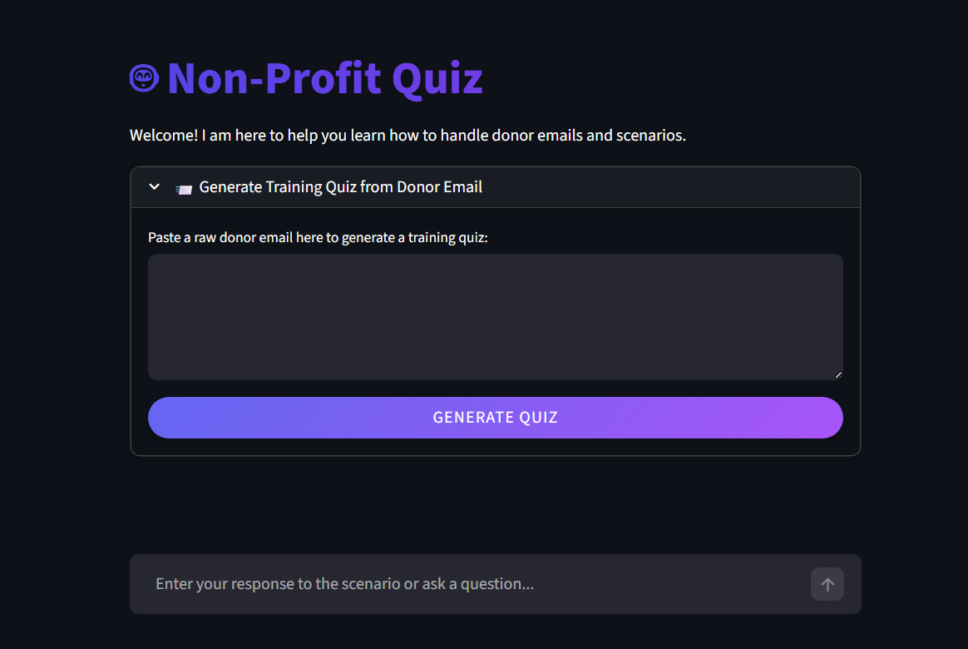

Tools & Technologies Used

Category | Technology Used | Purpose
Frontend | Streamlit | User interface
Backend | FastAPI | API handling & logic
Programming | Python | Core development
AI Model | Google Gemini (LLM) | Quiz & evaluation
AI Framework | LangChain | RAG implementation
Database | ChromaDB (Vector DB) | Store document embeddings

3. Results & Output

1. Screenshots / Outputs
The system provides the following outputs:
- Quiz generation interface with MCQs
- Answer submission interface
- Result page showing:
  - Score
  - Correct answers
  - Explanations
  - Suggestions

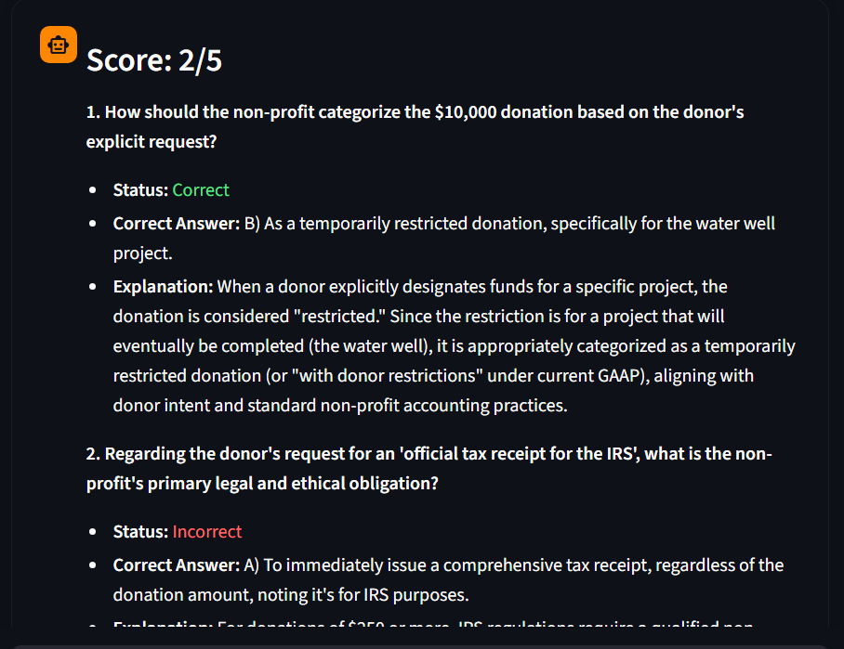
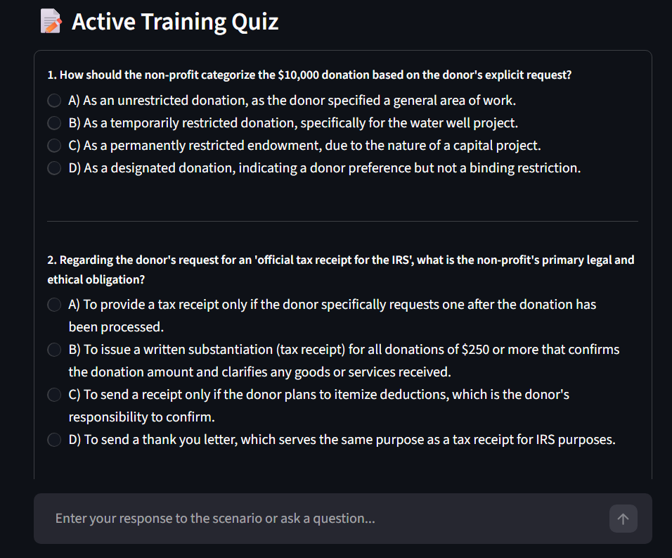

2. Reports / Dashboards / Models
- AI-generated quiz model
- Evaluation report including score and reasoning
- Feedback report with improvement suggestions

3. Key Outcomes
- Improved understanding of donor communication
- Enhanced learning through interaction
- Real-time evaluation and feedback
- Reduced manual training effort
- Better decision-making skills for users

- Increased efficiency in training processes

4. Conclusion
The Non-Profit Quiz/Tutor Bot demonstrates how AI can be effectively used to enhance training systems in the non-profit sector. By transforming donor emails into interactive quizzes and providing detailed feedback, the system improves user understanding and communication skills.
The integration of LLMs and Retrieval-Augmented Generation (RAG) ensures that the system delivers accurate, context-aware responses based on internal organizational knowledge. Overall, the project highlights the potential of AI in creating intelligent, scalable, and efficient educational solutions.

5. Future Scope & Enhancements
- Implementation of user authentication system (JWT)
- Support for multiple languages for global usability
- Integration of voice-based interaction
- Development of analytics dashboard for performance tracking
- Mobile application development (Android/iOS)
- Integration with CRM systems for real-time donor data
- Addition of gamification features like:
  - Badges
  - Rewards
  - Leaderboards
- AI chatbot for continuous learning support

